
Billing Information:

Date:

Name:
Practice:
Address:
City, State, Zip:
Telephone:
E-mail:
Publication/Rates:

Online Dental Classifieds: Ad will appear online within two business days. The ad will run for 2 consecutive months on CSDA.com and it will automatically expire after 2 months unless renewed. CSDA members are eligible for six FREE Dental Classified ads per year (50 word limit). Ads over 50 words will be charged $1 for each additional word. After six ads are placed, members will be charged the same rate as non-members. For non-members, each ad costs a flat fee of $60 for the first 50 words or less, and $1 for each additional word.

If at any point during the 2 month run of the ad, the advertiser wants to move the ad to the top of the classified page they will have to pay for the ad in its entirety, forfeiting any remaining time on the 2 month run and only receiving the new ad purchased time. As a member benefit, CSDA Members can request to have their ad moved up once during the two month run time at no additional fee.

**If you are placing an ad, which includes photos, those photos must be supplied as one PDF file. There is a photo fee of $20. Please add this to the cost of your classified ad. This is in addition to the word count.

Type of Ad Submission: (Mark with an X)

Offering a position Seeking a position Practice/Equipment for sale

Other Inquiries
Classified Ad to Read: Type ad in box below. Please include a brief headline and contact information for replies.
You may attach a separate word document if it does not fit.
Salary Disclosure Law Takes Effect October 1, 2021 - A new Connecticut law requiring employers to disclose salary ranges. You do not need to supply that information to us to submit your classified ad, but must be aware that this information needs to be disclosed if asked.

Salary Range:

*E-mail submission or online form submissions are preferred. Please email your completed form to kwright@csda.com. To e-mail this form, save it to your desktop and attach it to an e-mail.

There is a $20 admin fee if you submit a classified form via fax, PDF or mail.
Payment: (Mark with an X)
CSDA Member? Yes No

* Classified ads are free for CSDA members (6 per year/50 word limit)
Check enclosed made payable to the Connecticut State Dental Association
Credit Card
Please call the CSDA with your credit card information. Credit cards will NOT be accepted by email.
* Payment must be made in full for all classified ads. If advertising/payment deadlines fall on a holiday or weekend, deadlines will be extended to the next business day. All credit card transactions are processed in U.S. dollars. Once ad is placed, refunds will not be issued. The CSDA reserves the right to accept or withdraw an ad at its discretion. The CSDA will hold all advertisers liable for all payments under this contract.
Signature (please type or print name) Date
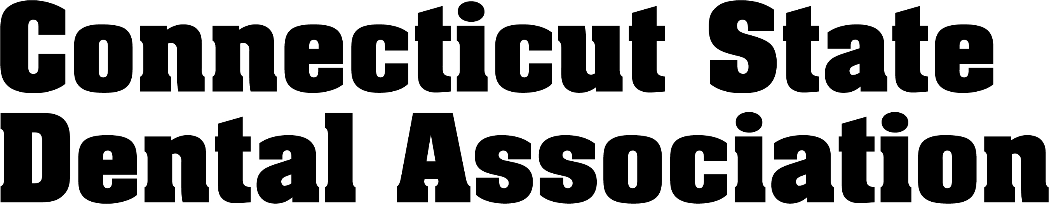
CSDA Staff Signature__________________________________________ Date

Note: The Dental Classified Service neither investigates applicants or offers being made nor assumes any responsibility for omissions, prior sale, change of conditions, position being filled or practice being sold without notice, and to any special conditions imposed by users. The Dental Placement Service reserves the right to edit, copy, and to accept, delete, or withdraw ads at its discretion.

